Project Development Phase

1. Introduction
The Project Development Phase involves implementing the planned Script-Controlled ACL in ServiceNow. During this phase, the required table, field values, users, roles, and access conditions are configured.

2. Objective
- To develop the Script-Controlled ACL in ServiceNow.
- To configure the required table and field.
- To implement field-based access restrictions.
- To create and configure the ACL script.
- To ensure unauthorized users cannot access restricted records.

3. Activities Performed
- Created or selected the required ServiceNow table.
- Identified the field whose value controls record access.
- Created the required users and roles.
- Created an Access Control Rule (ACL).
- Configured the ACL for the required table and operation.

4. Expected / Produced Output
- Script-Controlled ACL successfully created.
- Required table and field configured.
- Field-based access condition implemented.
- Authorized users are allowed to access records.
- Unauthorized users are prevented from accessing restricted records.
- ACL functionality verified through testing.
- Working access-control mechanism produced.

Screenshot

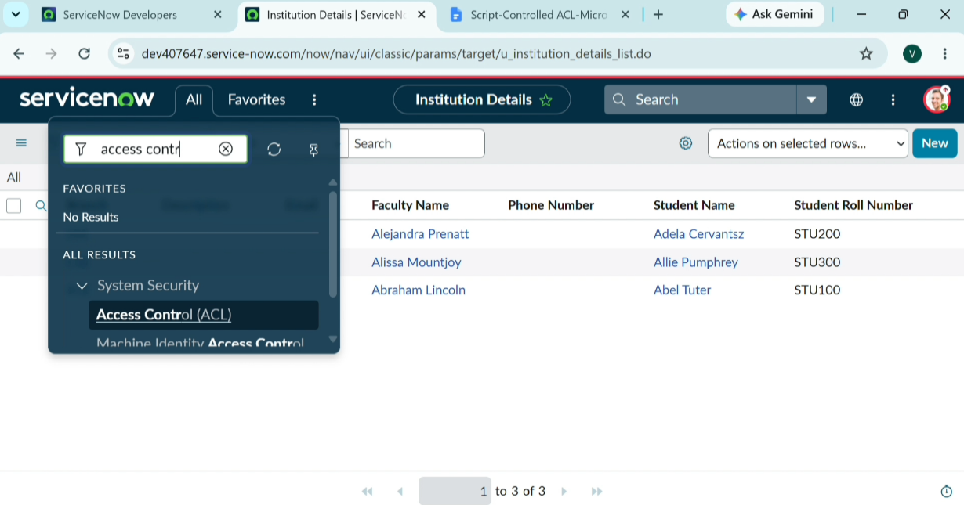
- Data Flow Diagram

